Appending to text files

# Code snippets .

Appends to an existing file called players.txt and adds the player DragonShark on a new line

| 1  2  3 | file = open("players.txt","a")  file.write("\nDragonShark")  file.close() |
| --- | --- |

Imports the datetime function, creates an identifier for the current time, creates a variable to hold the current time in the specified format

| 1  2  3 | import datetime  currenttime = datetime.datetime.now()  timestamp = currenttime.strftime("%d-%m-%Y %H:%M:%S") |
| --- | --- |

Challenge 1 .Append a timestamped score

Before starting this challenge, make sure that you have the scores.txt file which can be found here:

<https://drive.google.com/file/d/1a9BALCv7JnQ9VfWUJD00TSW98ZNnSTGd/view?usp=sharing>

Use the code snippets above to create a program that performs the following:

* Prompts the user to enter their latest score
* Adds a new score entry to the end of the scores.txt file using the format shown below:

10293 recorded at: 30-04-2020 14:49:57

**Example input/output**

| Enter your latest score:  10293  >>> |
| --- |

**Example text file data**

A **new entry** should appear at the bottom of the file on a new line.

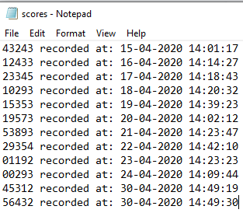

**Test your code then enter it below:**

**Note for assessor: this is just one example, there will be many variations from learners.**

| import datetime  print("Enter your latest score:")  score = input()  currenttime = datetime.datetime.now()  timestamp = currenttime.strftime("%d-%m-%Y %H:%M:%S")  newscore = (f"\n{score} recorded at: {timestamp}")  file = open("scores.txt", "a")  file.write(newscore)  file.close() |
| --- |

# Challenge 2 .Count letters in a text

Before starting this challenge, make sure that you have the romeojuliet.txt file which can be found here:

<https://drive.google.com/file/d/1a9BALCv7JnQ9VfWUJD00TSW98ZNnSTGd/view?usp=sharing>

Use the code snippets above to create a program that performs the following:

* Reads the contents of the romeojuliet.txt file
* Searches for all occurrences of the lowercase letter ‘a’
* Appends the text file with a message at the bottom in the following format:

Letter: a

Occurrences: 33

**Tip**: You will need to read the file, then append the file in separate steps.

**Example text file data**

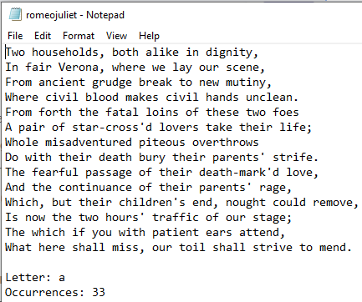

**Test your code then enter it below:**

**Note for assessor: this is just one example, there will be many variations from learners.**

| file = open("romeojuliet.txt", "r")  text = file.read()  file.close()  print(text)  occ = 0  for letter in text:  if letter == "a":  occ = occ + 1  file = open("romeojuliet.txt", "a")  file.write(f"\n\nLetter: a")  file.write(f"\nOccurrences: {occ}")  file.close() |
| --- |

# Explorer task . Improve noughts and crosses

Revisit your noughts and crosses game and add an extra feature where it will store who the last person to win was. The text file should append with the new winner at the end of each game.